**EXPERIMENT NO 4: Date:06/03/2023**

**AIM :**

Familiarization of linux command.

**C02 :**

Perform system administration task.

**Procedure :**

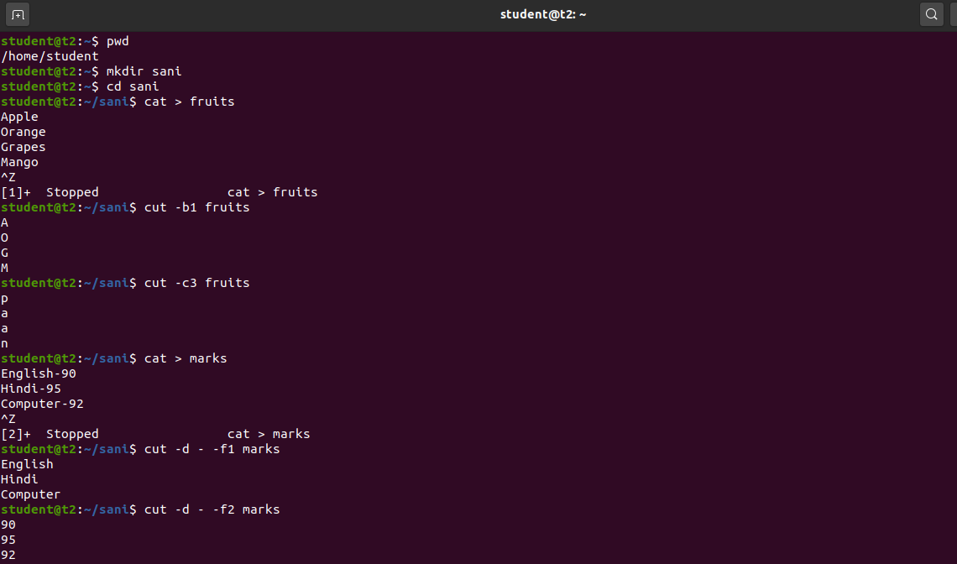

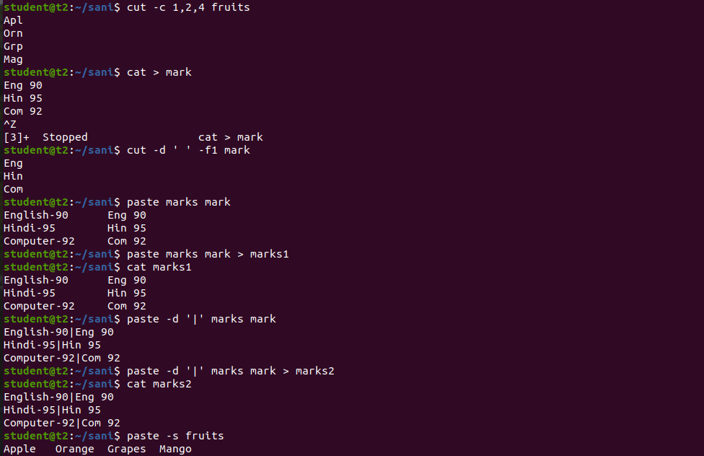

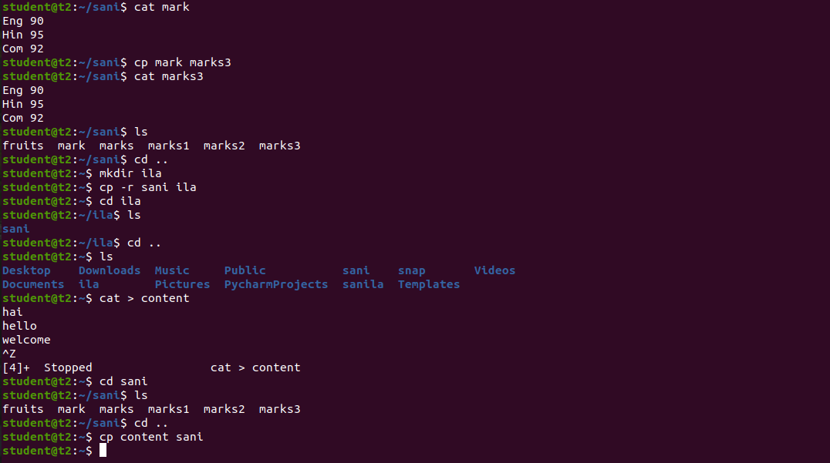

**Result:**

The program was executed and the result was successfully obtained. Thus CO2 was obtained.